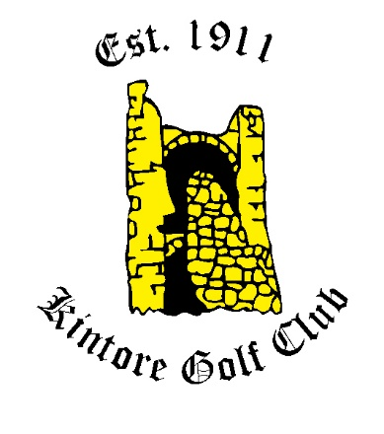

KINTORE GOLF CLUB SPONSORSHIP OF A HOLE 2018/2019

Subject to availability

- The cost of a sign advertising your business on each tee at one hole
  - £200 for 1 year (plus initial cost of the signs from Rood Signs Ltd)
  - £500 for 3 years (plus initial cost of the signs from Rood Signs Ltd)

- This will entitle your business to
  - 10 rounds of 18 holes of golf at £170 + VAT (normal price £300)
  - 25 rounds of 18 holes of golf at £400 + VAT (normal price £750)
  - 50 rounds of 18 holes of golf at £800 + VAT (normal price £1500)
  - 100 rounds of 18 holes of golf at £1600 + VAT (normal price £3000)
* This offer is for the sponsorship period only

Holes available

- 1st
- 2nd
- 4th
- 8th
- 9th
- 10th
- 11th
- 15th
- 16th
- 17th

